CERTIFICATE OF DELIVERY

DATE | 08/01/2026
EQUIPMENT | 4G Analyzer

PHOTO | ITEM | CANT
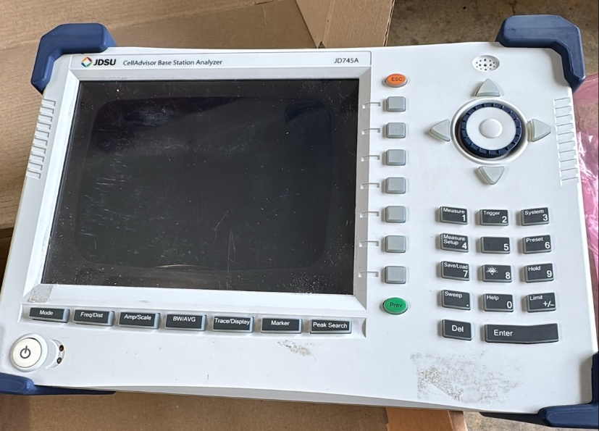 | JD745A  CellAdvisor Base Station Analyzer  JDSU  EFB13937 | 1

COMMENT:

